January 2022
Dear Parent/Carer,

Re: ‘Matilda JR.’ whole school production 2022
BACK STAGE CREW

Back stage crew are asked to wear the following:

Girls and Boys:
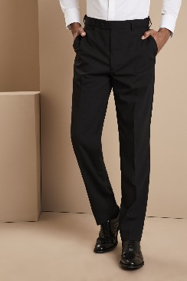
1. Black long-sleeved t-shirt
2. Black trousers
3. Black socks
4. Black shoes/trainers
NO LOGOS

If you have any questions, please ask.

Yours faithfully,

Mrs Ventress
Costume Manager

justine.ventress@charlton.uk.com

