January 2022
Dear Parent/Carer,

Re: ‘Matilda JR.’ whole school production 2022
PARENTS

Performers have been asked to provide their own basic costumes:
No thank you | Yes please
GREEN/TEAL  - Black  - ‘school’ shirts/uniform | Colours  Patterns  Stripes  ‘grown up’ clothes  smart denim  wealthy appearance
Girls:
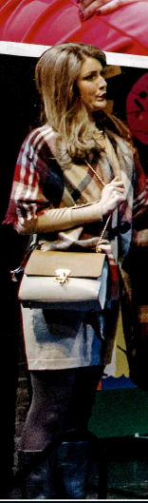
SUGGESTIONS:
Outdoor lightweight coat
Long outdoor jacket
handbag to hold/carry
skirt/smart jeans/trousers
cardigan
smart boots/shoes
jewellery
hair loose

Boys:
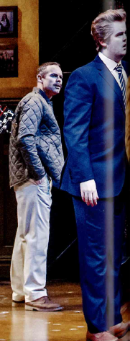
SUGGESTIONS:
Trousers/suit/smart jeans/trousers
Outdoor lightweight coat/ outdoor jacket
newspaper to hold/carry
brown shoes
jewellery
hair neat
tie
fake glasses

Any questions, please get in touch with me.

Yours faithfully

Mrs Ventress
Costume Manager

Justine.ventress@charlton.uk.com

