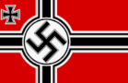
ADOLF HITLER
KNOWLEDGE ORGANISER
Overview  A photograph of Adolf Hitler from 1938. |  |  | Answers to Important Questions and Key Vocabulary
Adolf Hitler (1889-1945) was a German politician and the leader of the Nazi party. Between 1934 and 1945 he was the Führer (leader) of Germany.  He was the leader of Germany throughout World War II. Despite repeated warnings, he ordered the invasion of Poland in 1939, which started the war.  Hitler and the Nazis were also responsible for killing around 6 million Jews in the Holocaust, in addition to political opponents, Russian citizens and others.  These actions, in addition to many other crimes against humanity, have led many to label him one of the most evil people to have ever lived. It is estimated that he is responsible for the death of around 50 million people. | 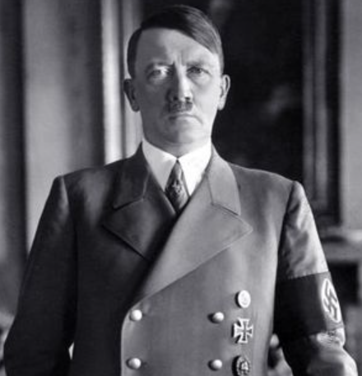 |  | What was Hitler trying to achieve? | 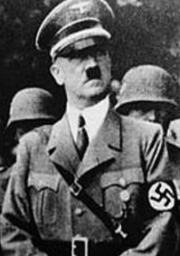  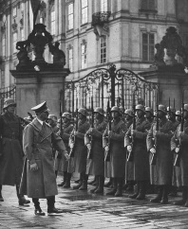 | -Hitler was angry that German leaders had surrendered in World War I. Like many Germans, he was unhappy that Germany accepted full responsibility for the War in the Treaty of Versailles, and that they had to make repayments that would cripple the country for years.  -Hitler believed that some races (e.g. whites) were superior to others (e.g. Jews). He thought that Jews were selfish, held too much money and power in society, and were not good for Germany. He wanted to rid the country of all undesirables to create his perfect ‘Aryan’ race. Hitler wanted ‘Lebensraum’ (living space) for the Germans, meaning that he invaded other countries. He believed these policies would make Germany the strongest nation on Earth. |  |  | Key Vocabulary  Politician  Führer  Public Speaker  Nazi Party  Holocaust  Jewish  World War II  Germany  Allied Powers  Axis Powers  Dictatorship  Lebensraum  Aryan
 |  |  | How did Hitler gain power? | 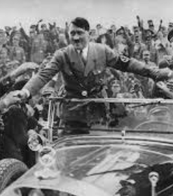 | -Many Germans were angry about the terms of the Treaty of Versailles, and were also poor due to an economic depression. They longed for Germany to be strong again. Hitler was a powerful speaker, who promised Germans that he would make the country powerful again. He was also ruthless, swiftly eliminating his enemies (at some points killing them) until Germany was under his complete command.
Times in His Life
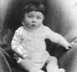  Early Life  -Adolf Hitler was born in Braunau Am Inn, Austria. This is near the border with Germany.  His parents, Alois and Klara, come from poor peasant families. Hitler was the fourth of six children.  -He was excluded from two schools as a youngster.  -He failed high school twice and left school in 1905. | 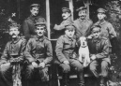  Young Adulthood  -In 1909 Hitler moved to Vienna to study Art. He claims he became an Anti-Semite here (there was a large Jewish population).  -He left Austria for Germany, and volunteered for the German army. He was awarded with the Iron Cross first class in 1918. He was shocked and angered when Germany surrendered. |  | How was Hitler defeated? | 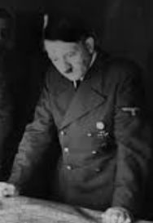 | -In the early parts of World War II, the Axis powers were winning, taking large parts of Europe.  -However, from 1942 the tide began to turn, and the Axis powers being pushed back by Germany.  -By April 1945, the Allies were closing on Hitler’s bunker in Berlin. Hitler married his long term partner, Eva, before taking poison to commit suicide.
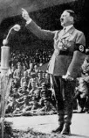
Rise to Leadership

-In 1919, Hitler joined the German Workers Party. After two years, he became leader. It became the Nazi Party. Hitler attempted a coup of the country, which failed.
-He was sentenced to five years in prison, but only served 9 months. Whilst in prison, Hitler wrote a book detailing his ideology with Rudolph Hess. It was called Mein Kampf (My struggle).
-Hitler’s ability as a public speaker won him further support. He was elected into the German government in 1933, as Chancellor. He began banning other political parties.
-He ended freedom of speech, and began invading other countries.
 |  |  | Top 10 Facts!
 |  |  | - Hitler did not have a happy childhood. Both of his parents died young, as did some siblings.  - Only one of his siblings survived childhood – his sister Paula.  - Hitler was known for always wearing a coat or jacket, even when it was very hot!  - As a painter, he produced hundreds of works throughout his life.  - After being blinded by mustard gas, Hitler sank into a deep depression. He would cry a lot. |  |  | - Hitler had a cat named Schnitzel.  - The main countries that joined Germany to make the Axis powers were Japan and Italy. Hitler admired the Italian leader: Mussolinii.  - After failing as an artist in Vienna, Hitler had to live in a homeless shelter for a while.  - His partner was called Eva Braun. He married her just before they both committed suicide.  - It is thought that Hitler chose death rather than being captured by the Soviet Union.
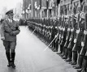  World War II  -Hitler ordered the German army to invade Poland, which led Britain and France to declare war on Germany.  -More countries joined both sides (the Allies and Axis).  -WWII ran for 6 years from 1st September 1939 to 2nd September 1945. It became the deadliest conflict in human history, with around 75 million people dying around the world. | 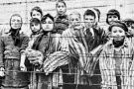  The Holocaust  -Hitler ordered the Nazi’s to kill 6 million Jews (2/3rds of the Jews in Europe).  -Many were sent to concentration camps and death camps. Most were killed in gas chambers, shot, or worked to death. Political opponents, disabled people & others were also killed.

1939: Invades Poland. WWII begins.
1934: Becomes dictator of Germany.
1941: Declares war against the United States.
1933: As Chancellor, begins the Holocaust.
1924: Sentenced to five years in prison for treason. Writes Mein Kampf.
1921: Elected leader of the Nazi party.
30th April, 1945 Hitler commits suicide in Berlin.
1914: Hitler volunteers to fight for Germany during World War I.
1907: Hitler’s mother dies of cancer. It affects him deeply.
1918: Temporarily blinded in a mustard gas attack.
Adolf Hitler Timeline
20th April 1889: Born in Braunau Am Inn, Austria.

