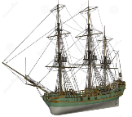
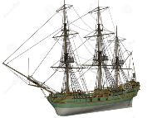
THE ATLANTIC SLAVE TRADE
KNOWLEDGE ORGANISER
Summary |  |  | Features of the Slave Trade |  |  |  |  | Key Vocabulary
The Transatlantic Slave Trade involved the enforced enslavement of millions of Africans and their transport to the Americas.  Slaves were often made to work in inhumane conditions with no wages. Many were beaten or killed by brutal owners, and had no rights in their new countries. Many didn’t survive the journey.  The trade had its roots as early as the 1500s, but was at its height in the 18th Century, under the operation of the imperial European nations (e.g. Britain, Portugal and Spain).  Countless African communities were decimated, whilst many European nations became extremely wealthy from the profits of the slave trade. | 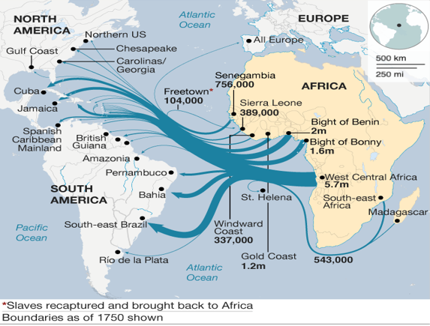 |  | THE TRIANGULAR TRADE | 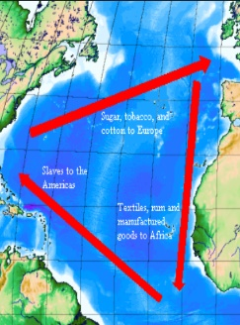 | The trade in slaves was called the triangular trade, because it had trade in three stages, marking a rough triangle between Europe, Africa and the Americas:  1. Manufactured goods from Europe, e.g. textiles and weapons, were taken to Africa where they were exchanged for slaves;  2. The transport of slaves from Africa to the Americas was known as the ‘Middle Passage.’  3. Materials produced as a result of slave labour in the Americas, e.g. sugar, cotton were brought back to Europe. |  |  | Atlantic  Slave Trade  Africa  Europeans  Americas  Slavery  Plantations  Culture  Triangular Trade  Slaver  Caribbean
 |  |  | SLAVE SHIP CONDITIONS | 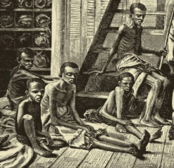  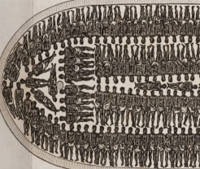 | -Enslaved people were captured in many different ways, including in battles, raids and kidnappings.  -Others were sold into slavery in order to pay debts.  -Once captured, slaves were often shackled together and made to walk to the coast in journeys that could last months, where they would be put aboard slave ships.  -Slave ships were deliberately designed to fit as many slaves on board as possible (see bottom image on left).  -Conditions were truly inhuman. Men, women and children were crammed on board with very little food or hygiene facilities. The average time to sail the Atlantic took 60-90 days, during which many died of illness, disease, hunger or injury. Of 12.5 million sent by slave ships between 1526 and 1867, only about 10.7 million arrived.
Major Events
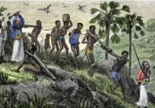  Pre-European Involvement  -Prior to Europeans arriving in Africa, a slave trade within Africa was already established, particularly in west Africa. Kingdoms often enslaved members of neighbouring communities.  -Early explorers from Spain and Portugal kidnapped Africans to be used as slaves in Europe and on their Atlantic islands. Tribe and kingdom leaders in west Africa were often complicit with the trading. | 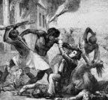  Tacky’s Rebellion (1760)  -Tacky’s rebellion was an uprising of slaves on the Caribbean island of Jamaica from May to July of 1760. Tacky had previously been a king of an African village. He planned to overthrow the slavers and create his own nation. Whilst the rebellion had considerable success early on, militia were put in place to bring the rebellion down. Tacky was killed and his followers committed suicide. |  | PLANTATIONS | 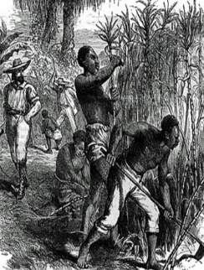 | -Upon arrival, most slaves were placed into forts owned by Europeans, where they could be bought by owners.  -Many went to work in plantations, where conditions were exceptionally harsh. Slaves worked from dawn until dusk, with very little food, and were whipped for lack of effort.  -Slaves who disobeyed even in small ways were severely punished. In some countries slaves could be killed legally.  -Runaways could be hanged or maimed, whilst they could receive a set number of lashes for particular ‘crimes.’
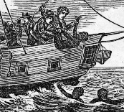  The Zong Massacre (1781)  -The slave ship Zong was carrying 470 enslaved people – more than it could handle. Many began to get sick.  -The sickness was spreading to the crew. So, to save themselves, the remaining crew threw 132 sick or dying people into the ocean. Another 10 jumped in with them. No one was ever charged with murder. | 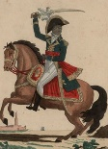  Haitian Revolution (1791-1804)  -The Haitian Revolution was a slave revolt against French colonial rule in Haiti.  -One of the leaders of the uprising was former slave Toussaint L'Ouverture.  in 1804: the only slave uprising that led to the foundation of a state that was free from slavery and ruled by non-whites.
 |  |  | Top 10 Facts!
 |  |  | - The first country to ban the slave trade was Denmark, in 1792.  - In the 18th Century, Britain was responsible for 2.5 million of the 6 million slaves transported.  - Of the 3 million slaves that British slave traders bought or sold, around 300,000 did not survive the journey across the Atlantic.  - The life expectancy for slaves living in Brazil was only around 23 years.  - The five countries most active in slave trading were Portugal, UK, France, Netherlands & Spain. |  |  | - The destination for most slaves was not actually the USA. Around 48% were sent to the Caribbean and 41% to Brazil.  - Many slaves were expected to work for 48 hours at a time during harvest.  - The last known Atlantic slave ship, carrying captives to Cuba, travelled in 1866.  - A lady called Harriet Tubman is thought to have liberated over 300 slaves.  - In total, the Atlantic Slave Trade lasted around four and a half centuries.
The Fall of the Atlantic Slave Trade

-Throughout the 18th Century, opposition began to gather against the slave trade in Britain, America and parts of Europe.
-The Committee for the Abolition of the Slave trade was led by William Wilberforce, Granville Sharp and Thomas Clarkson. Whilst Britain became a leading force in abolishing slave trade, it cannot be forgotten that Britain had been one of the most active slave-trading nations of all.
-Denmark was the first country to ban the slave trade, in 1792, which took effect in 1803. Britain banned the slave trade in 1807. Slavery to the Spanish colonies continued until much later in the 19th Century.

1760 – First protest against the slave trade.
1801-1853: Other countries gradually agree to ban slavery.
1791-1804: Haiti Slave Revolt led by Toussaint l’Ouverture.
1789 – UK bans slave trading.
1787 – Committee for Abolition of Slave Trade formed in UK.
1787 – First shipment of prisoners to Australia.
1672 - The Royal African Company is founded to provide slaves to British colonies.
1619 – The first shipload of Africans arrives in Virginia USA.
pre-1500CE – When Europeans arrived in Africa, they found an established slave trade.
1772 – James Somerset escapes from his owners and is freed by a court.
Timeline

