27th August 2020

Dear Parent/Carer,

Start of Term and September Re-opening Details

I hope you and our students have managed to take some time away from the headlines, and found time to relax and recharge, ready for a return to school following our home learning experiences.

It has been a very challenging summer in respect to the ever-changing education landscape in terms of exam results and Coronavirus guidance. I want to take this opportunity to congratulate our students on the results they received, there were some outstanding achievements, which we will look to celebrate when we can.

As with all new school years we welcome a number of new staff to Charlton, I am sure you will all make them feel very welcome:

- Mr Evans – Vice Principal and Maths
- Mr Wakelin – Assistant Vice Principal and PE
- Miss Knight - English
- Mrs Candlin – Computing and IT
- Mr Blasczyk - English
- Mrs Savage - Maths
- Mr Sloan – Cover Supervisor
- Miss Woodward - Librarian
- Miss O’Hanlon - Drama
- Mrs Groves - History

Plans from September

Our plans remain largely unchanged as to those shared with you in July. We have been working with our Governors, unions and the Learning Community Trust, to put a plan together that provides as much normality to the school day as possible, whilst meeting the expectations laid out in the Government guidance, found below:

https://www.gov.uk/government/publications/actions-for-schools-during-the-coronavirus-outbreak/guidance-for-full-opening-schools

It is vital that either staff or students who display Coronavirus symptoms do not attend school. The medical advice is clear, you must self-isolate if you have coronavirus symptoms, or live in the same household as somebody who does. The main symptoms of Coronavirus are:

- high temperature – this means you feel hot to touch on your chest or back (you do not need to measure your temperature)
- new, continuous cough – this means coughing a lot for more than an hour, or 3 or more coughing episodes in 24 hours (if you usually have a cough, it may be worse than usual)
- loss or change to your sense of smell or taste – this means you have noticed you cannot smell or taste anything, or things smell or taste different to normal

If you have one or more of these symptoms, you must self-isolate straight away for 10 days, or longer if you still have symptoms other than cough or loss of sense of smell/taste. If you live in the same household as someone with coronavirus symptoms, you must self-isolate straight away for 14 days. Anyone with symptoms should seek a test and inform school of the outcome.

Until further notice, parents or other adults cannot enter the Charlton building, including reception, unless attending a pre-arranged meeting. Contact with school should be made via telephone or email in the first instance.

Start Dates

The school year will start on Wednesday 2nd September for Year 7 only, Thursday 3rd September for Years 7, 10 and 11, and Friday 4th September for all year groups. This staggered start will allow us to incrementally build the number of students on the school site to test the plans and procedures in place.

Students are to return in full school uniform, the guidance states clothing does not need to be washed more than normal. Students are to wear PE kit to school on the days they have core PE; please bring a second pair of trainers that can be kept clean to wear in school.

We have staggered start and finish times for different year groups, and different entry and exit points, these will remain in place until further notice. Students who arrive early should remain in the school grounds, outside of the building, maintaining social distancing following Government guidance:

Year | Start Time | Finish Time | Entry and Exit Point
7 | 08:40 | 14:50 | Main Entrance
8 | 08:45 | 14:50 | Back Gate by PE
9 | 08:50 | 15:00 | Main Entrance
10 | 09:00 | 15:10 | Main Entrance
11 | 09:00 | 15:10 | Back Gate by PE

Any students who travel to school using the dedicated school bus services (either Arriva or A-Star Transport) can enter on arrival through the front doors and remain in their transport groups on the tables outside Sc9 until the times above. Additionally, they can wait in this area at their finish time if this is earlier than the bus pick-up time.

Guidance has been shared separately by the Local Authority on school transport but as a reminder, the following principles need to be followed by all students:

- Keep a safe social distance while waiting for transport
- Students should wear a face covering; children with Special Educational Needs, and or disabilities, will not be required to wear a face covering, however it is recommended where possible
- Sanitise hands before getting on and off the vehicle
- Dispose of litter responsibly
- If possible, use the same seat for each journey

If you bring your child to school by car, parents should use the top carpark and drop off point only and not drive down the side of the school. Parents must remain in their vehicles, parked in a bay. I have been asked to remind parents who use the surrounding roads as pick-up points, that Telford and Wrekin have taken over responsibility for parking enforcement and have received complaints about the use of Apley Drive. They will be monitoring the parking in the area and issuing fines for those who block access to driveways, or park illegally.

Revised School Timetable

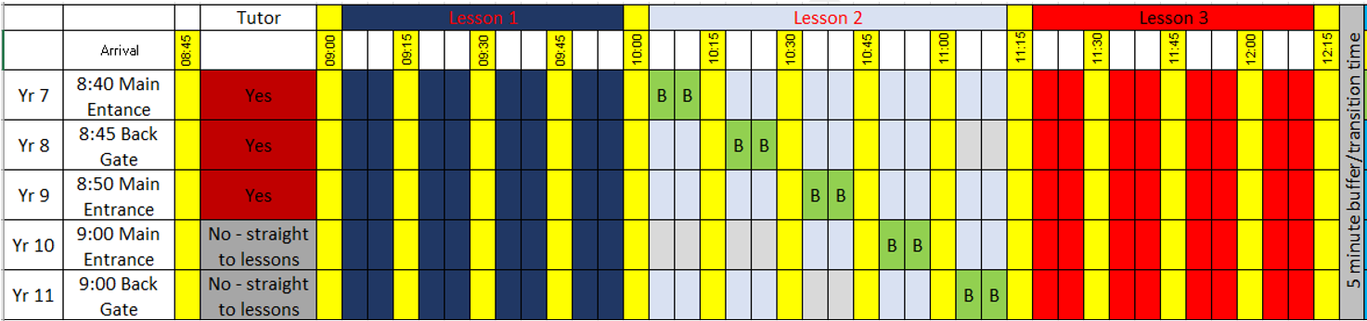

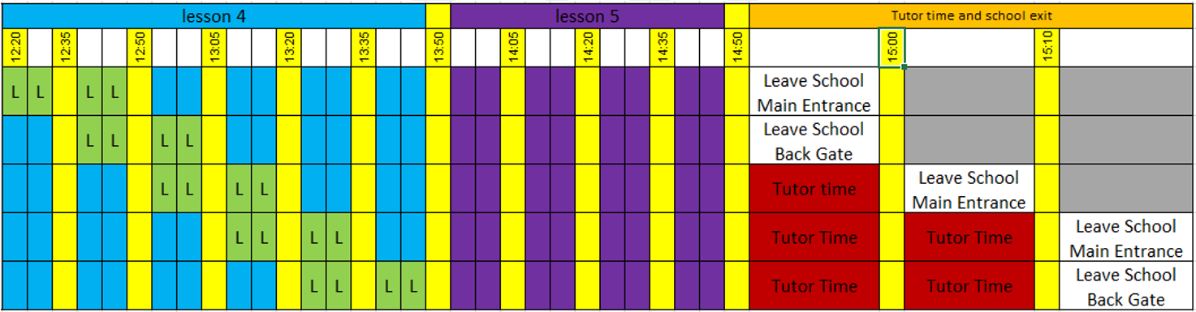

Once in school, students will follow their normal timetables and will move around the school, following a one-way system remaining in their year group “bubbles”. Following the latest Government guidance, the wearing of face masks remains optional at this time, this will change if we enter into a local lock down. Students who choose to wear a face mask should wear a plain mask, either the fabric reusable type or one of the readily available disposable masks.

Students are expected to wash or sanitise their hands on entering the school building and on entry to every classroom. In addition, on entering classrooms, students will be expected to wipe down their own desk which will have been sprayed with a virucidal disinfectant by the teaching staff.

Break and lunchtimes are built into lesson 2 and lesson 4, respectively and are staggered to prevent prolonged close contact with students from other year groups. All year groups will spend time outside of the building every break and lunch, please ensure they have appropriate clothing for the weather.

Our canteen will be open but will be offering a limited menu in the first instance. Where possible, we would ask that you top up money for school meals via Parent Pay, rather than students bringing money into school, with the exception of Year 7 who can use money initially, until the Parent Pay accounts are activated in the first week. Students will be expected to sanitise their hands on entry to the canteen area. Students who bring sandwiches will eat these in the canteen area with the rest of their year group.

For the first two weeks there will be no extra-curricular clubs, including breakfast and after school clubs. These will be constantly reviewed and brought in following guidance produced for out of hours activities, including those from the individual sport’s governing bodies.

All students will receive a briefing assembly on their first day in school explaining fully the expectations on them and the policy and procedures in place. The Learning Community Trust (LCT) have approved our opening plans for September, this document along with the LCT generic risk assessment can be found on our website here http://charlton.uk.com/parent-student-information/covid-19-information

You may have seen that the Government has launched a back to school campaign, further information from them about returning to school is available at the following website: https://www.gov.uk/government/publications/what-parents-and-carers-need-to-know-about-early-years-providers-schools-and-colleges-during-the-coronavirus-covid-19-outbreak

All of our school policies will be in operation, we will share changes to the behaviour and evacuation policies with students on their first day. These are necessary to uphold the new procedures in school, to provide a safe environment for all our school community.

We look forward to welcoming you back in school.

Kind regards

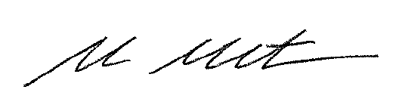

Mr A McNaughton
Principal

