Y 7 Medieval knowledge organiser!
Medieval Key people and useful bits!
Heaven and Hell | 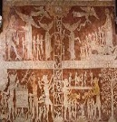 | Most people in Medieval England were Catholic Christian. Within most villages and towns, you would find a Church, with a Priest. As many people could not read or write, pictures were used to teach people about leading a good life, in order to avoid going to hell when they die. Church services were held in Latin and people had to give the priest a tithe- one tenth of food that was produced by them.
Monastery | 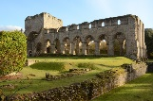 | A Medieval monastery was a place of worship for monks and nuns. Monks would spend their time praying, writing books and caring for others, such as the homeless, poor and unwell. Monks and nuns played an important role in the community. Monasteries were almost like places of hospitality- before a modern hospital system! Although most are now in ruin, there are some monasteries within Telford. The nearest one is Buildwas Abbey, near Ironbridge!
Richard I  1189-1199 | 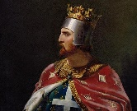 | The son of Henry II and King of England and parts of modern France (Angevin Empire). Famous for being the leading King on the Third Crusade to take back the holy land of Jerusalem for the Christians, Richard was a great soldier and brilliant military campaigner. However, he only stayed in England for six months, and was said to sell off most of England’s land to pay for the Crusade. He died unexpectantly when shot with an arrow to the chest, after inspecting one of his castles in France
Crusades  1096-1250 | 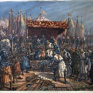 | Between 1096-1250 there were seven different ‘wars for the Christian Cross’- also known as the Crusades. They were a series of wars between Christians and Muslims, in order to claim holy lands such as Jerusalem for one religion. The most successful was arguably the First Crusade. Against many odds, thousands of pilgrims and knights walked over 1000 miles to take Jerusalem in 1099. It was only held by the Christian for 80 years, so other Crusades followed!
Medieval Medicine | 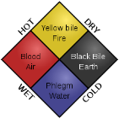 | Medieval doctors used the Four Humours to try and explain why people were ill. Each person had four parts that needed to be in balance- blood; phlegm; yellow bile; black bile. If one of the humours was out of balance, a person was deemed to be sick. Doctors also used urine charts to check what type of illness and disease a person could have. Poorer people might not afford a doctor, so they would have to go to an apothecary to get an herbal remedy, like honey or lavender. People who had a broken leg or arm would have to go to see a barber surgeon to get their limbs chopped off- just after getting a haircut!
Peasants Revolt- 1381 | 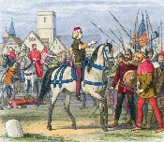 | After the Black Death, Peasants who survived could demand more money for their work. However, after a new poll tax was introduced, the peasants had enough and refused to pay it. It led to thousands of peasants (led by Wat Tyler) marching to London to meet Richard II, to demand an end to the Feudal System and more rights to peasants. Although Richard initially agreed, the Mayor of London was angered by disrespect of Tyler and the loud peasants. Tyler’s head was cut off and the revolt was over. Peasants never dared to challenge the king again for hundreds of years!
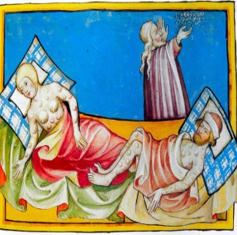
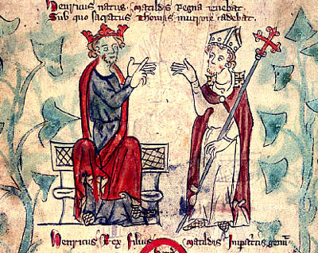
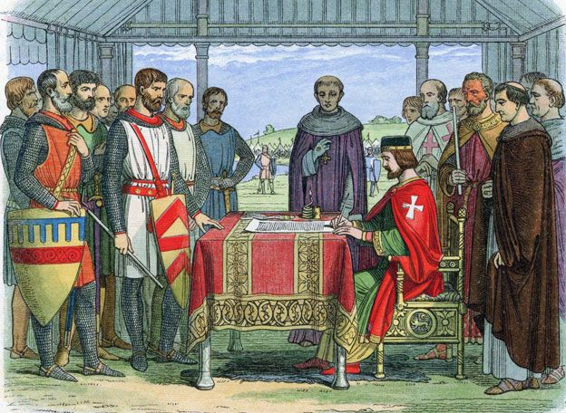
What caused this deadly disease?
Although people in England did not know, the Bubonic and Pneumonic Plague came from parts of modern China and Mongolia. It was a deadly disease that passed through the air or fleas on rats. Trade ships travelled to Europe and then England. By August 1348, the coastal towns of England and then within months, across England. This became the deadliest disease England had ever seen!
How did people try to stop it, treat it and what impact did it have?
As England was mainly Christian, Priests told people to pray for a miracle and not get the disease. Also, people looked like the position of the planets and thought that if they were out of place, then a disaster could strike. Thirdly, people really thought the Black Death was God’s punishment for too many people leading a life of sin! People could get big black spots that could pop after a few days, or that their lungs would rot from within. Within a few days the victim would be dead. People tried all sorts of ‘cures’ like rubbing onions on your body or drinking vinegar and mercury. Some people just ran away to the countryside to get fresh air! By 1350 when the disease ran its course, it had killed on-third of England’s population and over 20 million people in Europe.
Magna Carta- Main bits!
-Don’t interfere with the Church
-Stop unfair taxes and not ask for more
-All trials should be fair
King Henry II became king of England in 1154 and was best friends with Thomas Becket. They hunted, got drunk together and played cards. Becket was made Chancellor and then Archbishop of Canterbury- the most important religious job in Medieval England! Henry was loyal but could lose his temper very easily. Eventually he fell out with his friend, due to Henry trying to sentence corrupt priests in the Kings courts, rather than more lenient priests’ courts. Becket refused to help Henry, as he said religion was separate to the crown. Becket then ran away to France and did not return to England for six years! When he came back, he immediately annoyed Henry again as he excommunicated (sent away from the Church) some bishops who were now working for Henry. When the king heard of this, he flew into one of his rages, and shouted “who will rid me of this troublesome priest?” Four of his knights overheard this, and they rode to Canterbury Cathedral on the 29th of December 1170. There, the knights struck four brutal blows to Becket’s head until it was ripped off. The leader of the Catholic Church in England was dead. Did the King of England and former friend organise the murder, or was it a case of miscommunication?
Key Event Three- The Black Death!

Key Event Two- King John and the Magna Carta
King John was the youngest son of Henry II and brother to the famous Richard I ‘Lionheart’. Unlike his brother, John was a bad soldier, lost land in France and found it difficult to build trust with many people, including his own barons who helped to run England. Even during his lifetime, he was nicknamed BAD King John, LACKLAND and SOFTSWORD! It got so bad that many people could not afford to pay his high taxes that were used for war. He even upset the Pope by trying to choose his own bishops. In 1215, John’s barons had enough of his scheming ways. They gave him a choice- either change his ways or be prepared to fight the barons. In the end the two sides met near London and the Barons presented their list of demands known as the Magna Carta. After some days of discussion, John stamped his approval- he could not even write, so just had to stamp his seal of approval! Although John broke the agreement within a year, many people say that this was the start of modern democracy, where one ruler cannot do what he wants all of the time. Even America has used Magna Carta in their own Bill of Rights!
Key Event One- King Henry II and Thomas Becket. Best of friends or worst of enemies?

