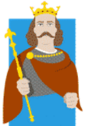
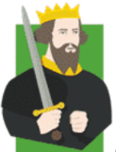
THE NORMAN CONQUEST
KNOWLEDGE ORGANISER
Summary  The Battle of Hastings section of the Bayeux Tapestry (1077), which depicts the Norman Conquest of England. |  |  | Answers to Important Questions and Vocabulary
The Norman Conquest of England was a military invasion of Britain by William the Conqueror.  William was the Duke of Normandy, who led troops to conquer England in October 1066, after defeating King Harold II at the Battle of Hastings. Harold was killed in battle.  The previous King, Edward the Confessor, had died in January 1066 without leaving a clear heir. His brother-in-law, Harold Godwinson, claimed the throne. Harold had already defeated another rival, the Norweigian King Harald Hardrada at the Battle of Stamford Bridge.  William faced several rebellions after his victory and was not secure on his throne until after 1072. | 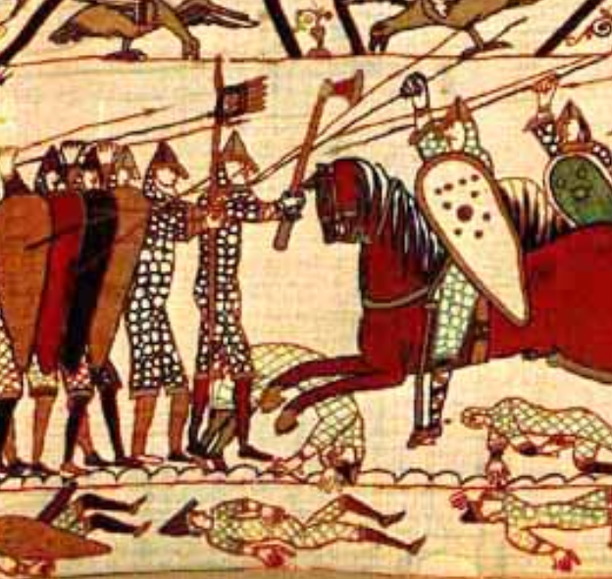 |  | What happened at the Battle of Hastings? | 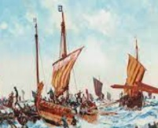  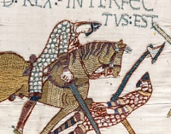 | William’s troops landed at Waveney in Sussex on 25th September. Harold’s troops were weary from the Battle of Stamford Bridge, and many stayed north as Harold marched to defend this new threat. The battle is thought to have begun at around 9am and lasted all day. Although the numbers on both sides were probably about equal, William had cavalry and infantry, whereas Harold’s troops were mainly footsoldiers. Harold’s side were initially successful. William’s troops began to retreat, and as Harold’s forces pursued them, they were surrounded by the remaining Norman invaders. |  |  | Key Vocabulary  Normandy  William the Conqueror  King Harold  Harald Hardrada  Bayeux Tapestry  Battle of Hastings  Edward the Confessor  Feudal System  Castle  Monarchy  Domesday Book  Anglo-Saxon
 |  |  | How was King Harold II killed? | 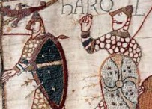 | There are conflicting reports about how Harold died on the battlefield. The Bayeux Tapestry appears to show death by an arrow to the eye, but other accounts detail an arrow to the head. Some sources state that William killed Harold, but most state that no one knows who struck the decisive blow.
 |  |  | How did the Bayeux Tapestry come into existence? | 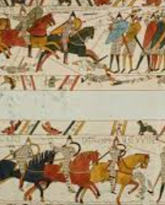  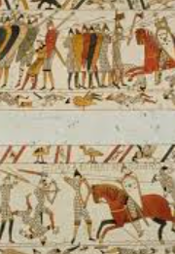 | The Bayeux Tapestry is an embroidered cloth that is thought to have been made in 1070s only a few years after the Battle of Hastings. Although it tells the story from the viewpoint of the conquering Normans, it is thought to have been made in England – not Bayeux. It is likely that it was commissioned by Bishop Odo, William's half-brother. In 1729, it was rediscovered by scholars when it was being displayed annually in Bayeux Cathedral. The tapestry is now exhibited at the Musée de la Tapisserie de Bayeux in Bayeux, which is in the Normandy region of France.
Key People
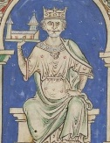  William the Conqueror (1028-1087)  William the Conqueror, also known as William I of England, was the first Norman King of England (between 1066 and 1087). Before becoming King of England, William was the well-respected Duke of Normandy, who had won several battles and had seen off revolts. It is thought that Edward the Confessor made William (a first cousin once removed) his heir in 1052, when he stayed at the Court of Dukes in Normandy for protection. However, after Edward died, William was upset to hear that these wishes were not respected by Harold Godwinson, Edward’s brother-in-law (it is rumoured that Edward may have changed his mind about his heir on his death bed). William made immediate plans to invade England, and defeated Harold at the Battle of Hastings in October 1066. William was a tough King, who imposed his own will on the nation. He also quashed several revolts and uprisings during his early reign. | 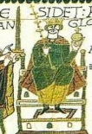  Harold Godwinson (1022-1066)  Harold Godwinson was King Harold II of England between 5th January 1066 and his death at the Battle of Hastings. Harold had inherited the Earl of Wessex title, making him the 2nd most-powerful man in England after the King (Edward the Confessor) When Edward died in January 1066, Harold claimed the throne for himself. He then defeated Harold Hadrada at the Battle of Stamford Bridge on 28th September. However, he was then killed in the Battle of Hastings on 14th October 1066 at the hands of the Normans, led by William the Conqueror. His death marked the Norman Conquest of England, and the end of Anglo-Saxon England. |  | How did William secure the throne after the Battle of Hastings? | 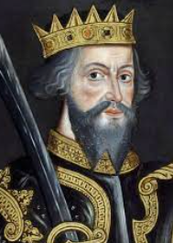 | Despite nobles submitting to William after the Battle of Hastings, rebellions persisted for many years. In 1067 rebels were defeated in Dover, and in 1068 he besieged rebels in Exeter. In May 1068, his wife Matilda was crowned Queen, which signalled his growing security on the throne. There were major uprisings in 1069, from those in both Northumbria and the south-west. In 1070, William had to see off an invasion from Sweyn II of Denmark, whilst in 1072 he confronted Malcolm of Scotland to ensure his compliance.
 |  |  | Top 10 Facts!
 |  |  | - They were called the Normans because they came from the Normandy region of France.  - William published the Domesday Book, which gives a lot of information about the people of England in the 11th Century.  - The Bayeux Tapestry measures 49.5cm wide and 70 metres long! It shows 72 events.  - The Normans built wooden houses covered in mud, dung and straw.  - They also built many large stone castles. |  |  | - The most famous Norman castles include Windsor Castle and the Tower of London.  - William the Conqueror established the feudal system, in which people gave kings and lords money in exchange for protection and order.  - Within 20 years of the conquest, the entire English aristocracy had lost its land and wealth.  - William died in 1087 at the age of 59, whilst leading a campaign in northern France.  - The Normans ruled England for 300 years.
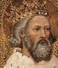
Edward the Confessor (1003-1066)
Edward the Confessor was King of England for 24 years. He gained his name for being religiously devout. When he died, he left no clear heir to his throne.
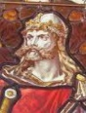
Harald Hardrada (1015-1066)
Harald Hardrada, also known as Harald of Norway, was the King of Norway between 1046 and 1066. Harald had succeeded in unifying Norway in a number of crushing victories. He had tried to also conquer Denmark since 1064, but was unsuccessful. Tostig Godwinson, Harold Godwinson’s brother, pledged allegiance to Harald and invited him to claim the English throne. He was initially successful in the Battle of Fulford, but then died in the Battle of Stamford Bridge 25th September 1066.

1072: William marches north to King Malcolm of Scotland, who agrees to be subordinate.
1070: The first Norman stone castle is built in Wales.
25th December 1066: William was crowned the King of England in Westminster Abbey.
14th October 1066: William defeats King Harold at the Battle of Hastings. Harold is killed in battle.
28th September 1066: William of Normandy lands at Pevensey on England’s south coast.
25th September 1066: Harold II defeats and kills Harald Hardrada at Battle of Stamford Bridge.
20th September 1066: Harald Hardrada defeats English at Battle of Fulford.
1069: William enforces Norman rule and there are numerous revolts.
1069/1070: William subdues several revolts in the north, including an invasion by Sven II of Denmark.
5th January 1066: Death of Edward the Confessor, with no clear heir.
Timeline of The Norman Conquest

