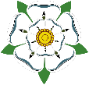
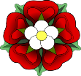
TUDORS and STUARTS
KNOWLEDGE ORGANISER
Everyday Life in the Period |  |  | Tudor and Stuart Monarchs - date of reign, biography, spouse info, and key facts.
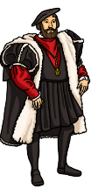  Tudor Lords – The wealthy in Tudor society lived increasingly rich and flamboyant lives:  -Fashion was important, with men wearing decorated doublets (jackets) with rounded fronts and slashed trunks. Women would wear kirtles (overskirts) over wooden frames (farthingales) and high collars.  -Food consisted almost entirely of meat, with few vegetables, with beer or wine amongst the predominant drinks of choice.  -Tudor Lords lived in huge mansions in the countryside (e.g. Hampton Court).  - Pastimes included jousting, hunting, dancing, and real tennis. | 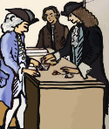  Stuart Lords – The wealthy in Stuart times also lived lives of increasing sophistication and flair:  -Cavaliers would dress flamboyantly, in the same manner as the Tudor Lords before them. Many women wore beauty spots on their faces. However, Puritans would dress in plain colours such as black and white, made of hard-wearing cloth.  -People began to eat salad, grown in their own greenhouses, and drink exotic drinks, such as tea from China and cocoa from Mexico.  -Gardens were formal places, often shapted in geometric designs, with fancily cut hedges and mazes.  -Recreations included horse-racing, board games and cards. |  | Henry VII  1485-1509 | 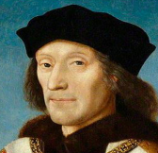 | Henry VII started the Tudor dynasty when he defeated Richard III in the battle of Bosworth Field in 1485. He was known as a serious man. He faced several challenges to his throne, but married Elizabeth of York, to end the War of the Roses. When he died, England was a rich and prosperous nation, and his son’s succession to the throne was not challenged. | Elizabeth of York  m.1486-1503 | In total, Henry had 9 children with his wife, including Henry VIII.
 |  |  | Henry VIII  1509-1547 | 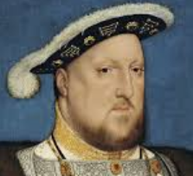 | Henry was the second son of Henry VII and became king after his brother (Arthur) died. A keen sportsman, Henry was lauded for his athleticism in his youth. He married his brother’s widow, Catherine of Aragon, but divorced her when she didn’t produce a male heir. To do so, he broke with Catholicism and formed the church of England. He went on to marry another five times, yet only had one male heir – Edward VI. | Henry had six wives – see the section on the left. | As many as 72,000 people were executed through his rein.
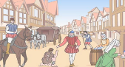  Life in Towns– The Tudor and Stuart era has been described as the ‘Golden Age of the Small Town’ as roughly 90% of people still lived in smaller dwellings. Small towns contained inns and dwellings for tired travelers (remember that travel was much more limited than now, even a trip to the next town was an undertaking) market places, and leisure facilities.  London notably improved in the 17th Century, as running water was made available from reservoirs for those who could afford it, and streets were lit by oil lamps after 1680. Most people travelled by boat on the River Thames, paying local ‘Ferrymen.’ | 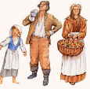  Life for the Poor – Life for poor people in this era was exceptionally harsh. For many manual labour jobs, such as farming, the day would begin at approximately 5am. Work would continue throughout most of the day, only breaking for mealtimes, which was normally some form of simple vegetable stew. As there was no welfare state, many who grew too old or weak were forced to beg, steal, or die.  Punishments for crime were brutal – death by hanging was given to anyone who stole over one shilling, beggars were whipped through the streets, and poisoners were boiled alive! The Poor Laws made life even harder for poor people, mostly punishing their poverty. |  | Edward VI  1547-1553  Lady Jane Grey 1553 | 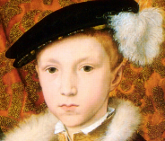 | Edward VI came to the throne at only 9 years of age. Therefore, the country was run by his protectors, firstly the Duke of Somerset (his mother’s brother) and then the Duke of Northumberland. Edward died aged 15 in 1553. Lady Jane Grey was chosen as Queen by the Duke, but the public did not approve. She lasted 9 days, before being removed and executed. | Did not marry | There is evidence to suggest that Edward was tall and healthy as a child.
 |  |  | Mary I  1553-1558 | 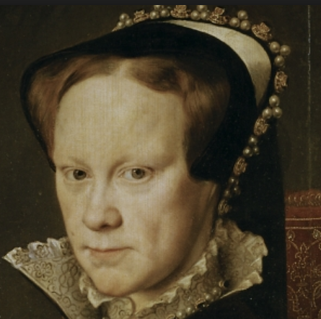 | Mary I was the daughter of Henry VIII and Catherine of Aragon and was a committed Catholic. She vowed to return England to Rome and Catholicism. These attempts were mightily aggressive, as she had over 280 religious dissenters burnt at the stake. Mary’s popularity decreased because of this, in addition to marrying Philip of Spain and losing Calais, England’s last French possession. | Philip II of Spain  m.1554-1558 | Mary was the first queen to rule England in her own right.
 |  |  | Elizabeth I  1558-1603 | 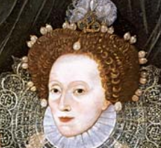 | Elizabeth I became Queen after her sister Mary died without an heir. The daughter of Henry VIII and Anne Boleyn, she reversed Mary’s re-establishment of Catholicism and upheld Protestantism. She had a long and successful reign, including the defeat of the Spanish Armada in 1588. However, she did not marry or have children, thus ending the Tudor line. | Did not marry | She may have owned as many as 2,000 sets of gloves!
Major Events and Key Information
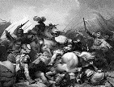  Battle of Bosworth – 22nd August 1485  The Battle of Bosworth was the last significant battle in the ‘War of the Roses’, a civil war that raged between the houses of Lancaster in York in the latter half of the 15th Century. The battle was won by the Lancastrians, and Henry Tudor thus became the first King of the Tudor period.  Richard of York had proven to be widely unpopular – he was originally acting as Lord Protector for Edward V at the request of his brother (Edward IV), however he declared the boy illegitimate and took the throne for himself. He was also believed to have been implicated in the murder of his wife. Henry seized this opportunity to stake his claim to the throne, garnering wide support and the help of Sir William Stanley to defeat Richard in battle and kill him. | Henry VIII’s Wives– In total, Henry VIII had six wives:  1st Wife: Catherine of Aragon – This marriage was annulled as Henry broke with the Catholic church in order to divorce. Their child was Mary I. 2nd Wife: Anne Boleyn – Anne gave Henry his second daughter, Elizabeth I. She was accused of treason and incest and was executed in 1536, 3rd Wife: Jane Seymour – Jane gave Henry the son that he desired (Edward VI) but died 12 days later, presumably from post-natal complications. 4th Wife: Anne of Cleeves – A German princess, it is believed they never consummated the marriage, which lasted 6 months. 5th Wife: Catherine Howard – Executed for adultery after just over 1 year. 6th Wife – Catherine Parr – Trusted by the King – outlived him by over a year. |  | James I  1603-1625 | 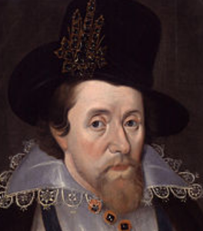 | The accession of James I united the countries of England and Scotland under one monarchy for the first time. He believed in the Divine Right of Kings and rejected any other interpretation of church doctrine than his own. The King James Bible is still in use today. When he died, the country was badly in debt. | Anne of Denmark  m.1589-1619 | James had become King of Scotland at just 13 months old.
 |  |  | Charles I  1625-1649 | 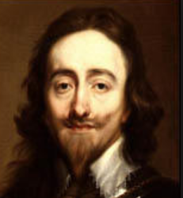 | Charles I embarked on war with Spain and France, however Parliament made it difficult for him to access the money to do so. He thus dismissed Parliament and ruled alone for 11 years. When he ran the country into further debt and recalled Parliament, it resulted in the Civil War and eventually his execution in 1649. | Henrietta Maria of France  m.1625-1649 | Charles I is the only English king to be executed.
 |  |  | Interregnum Oliver Cromwell  1649-1658 | 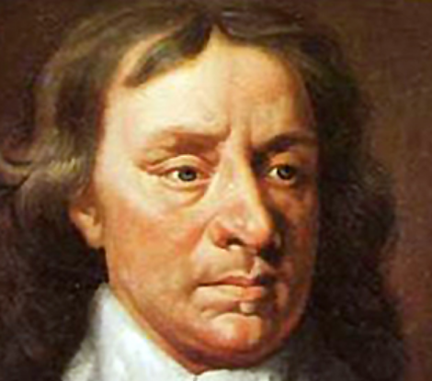 | Oliver Cromwell took on the title of Lord Protector of the newly-formed republic of England, known as the Commonwealth, and was not popular at home or abroad. He began wars in Ireland and the Netherlands, and colonies in the West Indies and Jamaica. His son and successor, Richard, had no wish to rule. | Elizabeth Cromwell  m.1620-1658 | It is a myth that Cromwell personally banned Christmas.
The Civil War – 1642-1651  The civil war pitted the Parliamentarians (the ‘Roundheads’) against the Royalists (the ‘Cavaliers’) over the manner of England’s government. The three major battles saw fighting between those supporting Charles I and those supporting Parliament. The war was eventually ended at the Battle of Worcester on 3rd September 1651, when the Parliamentarians won. The outcome of the war was several-fold – Charles I was put on trial and then executed, his son Charles II was driven out of the country, the country was ruled by the Commonwealth and then the Protectorate: Oliver Cromwell. | 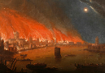  Great Fire of London – 2nd-5th September 1666  The Great Fire of London was a major conflagration that tore through London throughout the reign of Charles II. The fire consumed over 13,200 houses, St Paul’s Cathedral, and many, many churches. It is estimated that the fire damaged at least 70,000 of London’s 80,000 homes at the time. It is commonly held that the death-toll was relatively low (6), however many believe that the deaths of the poor were simply not recorded. The fire started at the bakery of Thomas Farriner on Pudding Lane. Afterwards, huge areas of London needed to be rebuilt – rebuilding schemes were widely encouraged by Charles.
 |  |  | Charles II  1660-1685 | 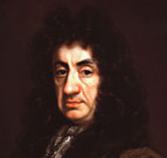 | Charles had attempted to defeat Cromwell and restore the monarchy in 1651, but was defeated and fled to France, where he spent the next 8 years. He was invited back to rule by Parliament in 1660 - known as the Restoration. Unlike Cromwell, he loved music and dancing. Charles made bad financial choices. | Catherine of Braganza  m.1662-1685 | Charles reportedly used to play with a toy spaniel at meetings!
 |  |  | James II  1685-1688 | 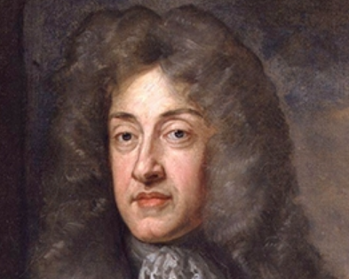 | James’ accession was despite attempts to bypass him (he was Catholic, so in violation of the 1673 Test Acts). The Duke of Monmouth and 300 others were executed after trials known as ‘The Bloody Assizes.’ This made him unpopular, allowing William of Orange to usurp him in the Glorious Revolution. | Anne Hyde  m.1660-1671  Mary of Modena  m.1673-1701 | James II died of a brain hemorrhage in France.
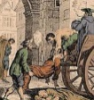  The Great Plague of London – 1665-1666  The last major episode of the bubonic plague to occur in England, the great plague killed around 100,000 people, almost a quarter of London’s population, in 18 months. It was reportedly initially caused by an infected rat flea bite. There was no duty to report deaths at the time – instead, parishes employed ‘searchers of the dead.’ For this reason, death figures may be somewhat inaccurate. | The Glorious Revolution – 1688-1689  The Glorious Revolution was the overthrow of King James II of England by a group of parliamentarians, to be replaced by William of Orange (of the Netherlands) and his wife Mary II (James’s daughter). James’s policies of religious tolerance had been met with opposition, and there was general concern over his Catholicism. William successfully invaded with his Dutch fleet to take the throne. |  | William III  1688-1702  & Mary II  1688-1694 | 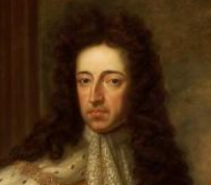 | William III and Mary II (daughter of James II) were made joint sovereigns of England following the Glorious Revolution. They were accepted by Scotland the following year, but not by Ireland, who remained loyal to James II. Mary died in 1694, leaving William to rule alone until his death in 1702. | William III and Mary II were joint monarchs | William and Mary had 3 stillborn children
 |  |  | Queen Anne  1702-1714 | 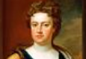 | Queen Anne was the sister of Mary II and was married to Prince George of Denmark. She was a committed Protestant and supported to Glorious Revolution. In 1707 the Act of Union joined England and Scotland. She left no heirs, ending the Stuart line. | Prince George of Denmark  m.1683-1708 | None of her 18 children survived infancy.

1588 – England defeats the Spanish Armada
1714 – Queen Anne dies – end of Stuart line
1689 – Glorious Revolution complete
1534 – ‘Act of Supremacy’
1553 – Mary takes the throne
1491 – Henry VIII born
1660 – Charles II returns to lead
1689 – Charles I executed
1642 – Civil War begins
1603 – Eliazbeth I dies – end of Tudor line
1485 – Battle of Bosworth
Timeline of Major Events

