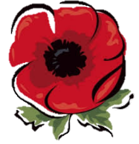
KNOWLEDGE ORGANISER
Inter-War Period
 | Major Events
 | Event | Image | Description | Date/s | Fact
 | Russian Revolution | 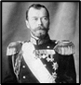 | Many Russians felt that their Tsar Nicholas II had let them down. Many people were suffering from starvation and Russia were losing many battles in WWI. The Romanov Royal family were arrested, and Lenin and the Communist Party stormed the Winter Palace and seized control making Russia a republic now called the USSR. | 1917 | Lenin had control from 1917-1924 and the Stalin took over the dictatorship until 1953.
 | Spartacist Revolution | 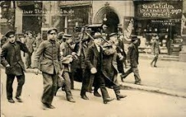 | In Germany there was a Revolution in 1919 after WWI to copy the Russian Revolution with the communists trying to take control of the government through taking control of the media however this failed and they were arrested and executed by the Friekorps (German volunteer army.) | 1919 | The leaders were Rosa Luxemburg and Karl Liebknecht
 | Kapp Putsch | 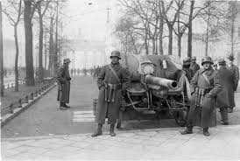 | This was another revolution in Germany to take control of the Government in Berlin but by the right-wing nationalist group as they though the Weimar Government was weak, which was proved by the population saving the government by holding a general strike to stop the Kapp Putsch | 1920 | The Leader was Dr Wolfgang Kapp.
 | Munich Putsch | 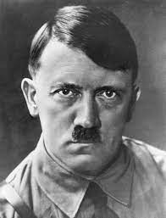 | After two failed revolution attempts in Germany, Hitler and his Nazi Party also tried to take control the Weimar Government but in Bavaria (Southern Germany) in Munich. He took government ministers hostage in a beer hall and the used his SA soldiers to try to take control of the city, however Ludendorff turned against Hitler and contacted the army. Shots were fired and Hitler was later arrested with a dislocated shoulder. Another revolution in Germany had failed. | 1923 | Hitler gained a lot of publicity in his trial after the Munich Putsch and spent his time in prison writing his famous book Mein Kampf
 |  | 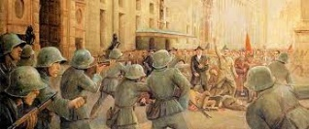
 | Revolution and Partition Ireland | 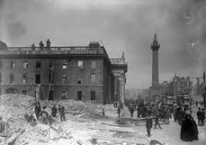 | Elsewhere in Europe Ireland were trying to gain Independence and had organised a revolution during WWI, while the British were fighting abroad. The Easter Rising took place in 1916 and was organised by the IRA to regain independence in Ireland. Partition finally took place in 1922 when Ireland split between the Republic of Ireland and Northern Ireland that was still controlled by the UK. | 1916-1922 | Ireland has been divided since the Tudors times over religion Protestants vs. Catholics and continues to be divided to some extent today.
 | American Prohibition | 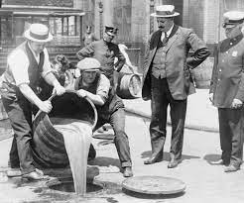 | Christian Temperance Movement helped to get the American Government to ban the selling and consumption of Alcohol from 1920 for thirteen years. However, this led to many people drinking and buying it illegally for the duration of the time period. Moonshine was alcohol that was made dangerously at home, bootlegging was the illegal movement of alcohol and speakeasies were illegal bars selling alcohol. Al Capone was one of many gangsters to make lots of money from prohibition. | 1920-1933 | AL Capone was known for his dangerous violence e.g. St Valentines Massacre in 1929. However, he also helped poor people with soup kitchens.
 | Wall Street Crash | 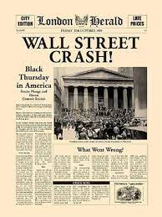 | America had experienced several years of prosperity and many people had lived beyond their means by borrowing money from banks to fund lavish lifestyles. But in October 1929 share prices in businesses started to fall and businesses and banks went bankrupt. For this reason people lost savings, jobs, their homes and suicide rates were high. America had also loaned money to countries like Germany, who now had to give all their money back | 1929 | The USA had made lots of money during WWI but many people had become greedy, buying things they couldn’t afford which led to many companies losing money and becoming worthless
 | Hungry Thirties | 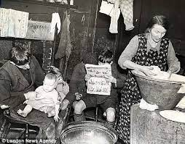 | Britain has often referred to the 1930s as the Hungry thirties as many people were unemployed in Britain. However, this wasn’t the case for everyone as some industries in the midlands e.g. car companies were making money and creating jobs and women were able to have better education and many more women entered professional jobs e.g. Doctors | 1930s | Since the Wall Street Crash many countries experienced the economic depression e.g. USA, Europe including Germany, Britain and France.

Timeline of Major Events
1916
Easter Rising fails to remove British control of Ireland
1917
Russian Revoltuion and creation of the USSR
11th November 1918
Armistice and end of WWI
January 1919
Spartacists fail to take control of Germany
28th June 1919
Treaty of Versailles is signed condemning Germany
1920
Kapp Putsch fails to take control of Germany
1920
Prohibition makes alcohol illegal in America.
1922
Ireland is split between Republic of Ireland and Northern Ireland
1923
Munich Putsch by Hitler fails to take control of Germany.
1929
Wall Street Crash causes the Great Depression
1930s
Hungry thirties due to unemployment

