KNOWLEDGE ORGANISER
Holocaust Overview |  |  | Important Events and Life in the Concentration Camps  THE HOLOCAUST
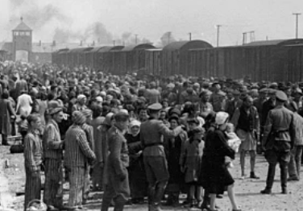  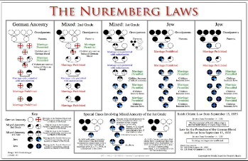  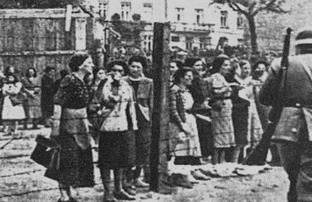  Holocaust Overview  The Holocaust was a genocide that took place during World War II, in which up to 17 million people were systematically exterminated by Nazi Germany and its collaborators. Around 6 million Jews were killed, in addition to Romani peoples, ethnic Poles and Slavs, homosexual men, and many other groups. The Holocaust took place in several stages:  Segregation  Jews were forced out of their homes and into ghettos. The ghettos were filthy, with poor sanitation, and were extremely overcrowded. Food supplies were low, and so many people starved to death.  Extermination  Victims were sent to concentration camps, where many were forced to work in hellish conditions, where many died. Others were sent to the gas chambers. Later, camps opened for the sole purpose of extermination.  Removal of Rights  The Nuremburg Laws (1935) meant that Jews were fired from jobs, forced to wear a yellow Star of David, stripped of German citizenship, and banned from German schools, amongst many other measures. |  |  | Germany is defeated in World War I | 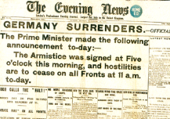 | After WWI, many Germans were angry; many did not approve of the Treaty of Versailles, which placed blame with Germany. The country was also poor in the post-war era, going through an economic depression. | When?  1918 onwards | Key Fact:  In the Treaty of Versailles, Germany lost significant land to France, Belgium and Poland.
 |  |  | Hitler Rises to Power | 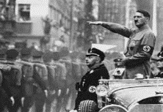 | Poor and disheartened post-war Germany provided a perfect platform for Hitler to grasp power, promising to make Germany strong again. With strong leadership and oratory skills, he rose to become Chancellor of Germany. | When?  Around 1945-1949 | Key Fact:  Hitler was an
 |  |  | The Warsaw Ghetto | 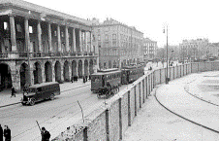 | The Warsaw Ghetto was the largest of all of the Jewish ghettos in German-occupied Europe during WWII. 400,000 Jews were imprisoned in only 1.3sq mi. of space. 392,000 died, either in the ghetto or after being transported to camps. | When?  October 1940 to May 1943 | Key Fact:  There was an average of 9.2 people per room in the Warsaw Ghetto
 |  |  | Prisoners Arrive at Auschwitz | 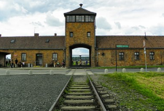 | Auschwitz was first constructed to house Polish political prisoners, who began to arrive in May 1940. From early 1942, Auschwitz II became a major extermination site. 1.3 million people were sent there, of whom 1.1 million died. | When?  Operational between May 1940 and January 1945 | Key Fact:  90% of the prisoners killed in Auschwitz were Jews. The camp was staffed by 7,000 SS soliders.
 |  |  | The Final Solution | 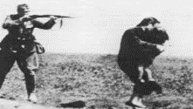 | The Final Solution was Nazi Germany’s plan for the genocide of all Jews. This resulted in the deadliest phase of the Holocaust, in which 2/3 of the Jews across Europe were killed. | When?  Formulated in Jan 1942 at the Wannsee conference | Key Fact:  About 2/3rds of the total number of Jews killed were already killed before Feb 1943
Key People
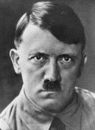  Adolf Hitler (1889-1945)  Adolf Hitler was a German politician who was the leader of the Nazi party, Chancellor of Germany from 1933-1945, and the Fuhrer of Germany from 1934-1945. As Germany was unstable following World War I, Hitler began to gain a loyal following through his populist ideas, powerful speeches and charisma. He believed that the superior ‘Aryan’ race was under threat from ‘inferior’ Jews, disabled people, and other minorities. When he gained power in 1933, Hitler immediately began implementing policies to ensure an ‘ethnic cleansing’ of Germany - making him the chief initiator of the Holocaust. Seeking ‘Lebensraum’ (living space) for Germans, he also ordered the invasion of Poland in Sep 1939 which triggered World War II, the most deadly mass conflict in history. As a result, he has become one of the most reviled people to have ever lived. He committed suicide on 30th Apr 1945, with his wife, as the war was lost. |  |  | Camps Liberated | 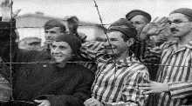 | As the Allies advanced across Europe, they found camps of sick, starving prisoners. The first camp liberated was Majdanak in July 1944, Auschwitz wasn’t until January 1945. | When?  Late 1944 – Early 1945 | Key Fact:  Many of the prisoners were so weak that they died trying to digest their first meal.
 |  |  | Hitler’s Suicide | 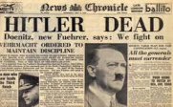 | With the Germans facing defeat, Hitler married his long-time love Eva Braun on 29th April. The next day, they committed suicide, reportedly by gunshot, although historians are unsure. | When?  30th April 1945 | Key Fact:  Some sources believe that Hitler died by poisoning himself.
 |  |  | Germany Surrenders | 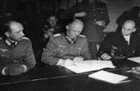 | The Allies had gradually forced the surrender of Axis troops across Europe in April and early May, 1945. On 7th May, Germany officially surrendered to the Allies, bringing to an end European fighting in WWII. | When?  7th May 1945 | Key Fact:  VE (Victory in Europe) Day is still held every 8th May.
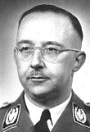  Heinrich Himmler (1900-1945)  Heinrich Himmler was the ‘Reichsfuhrer’ (Chief of SS police) throughout Hitler’s reign, and was considered as his deputy. He was responsible for the formation of both the Nazi death squads and the extermination camps. A committed anti-Semite himself, it is believed that many ideas involving the Holocaust were actually Himmler’s. Realising the war was lost, Himmler tried to negotiate with the Allies without Hitler’s knowledge. He committed suicide in British custody. | 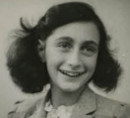  Anne Frank (1929-1945)  Anne Frank was a German-born Jewish girl, who wrote a diary about the time that her family fled Germany and hid in an attic, in Amsterdam in the Netherlands. After years in hiding, they were arrested, and taken to concentration camps. Anne died of Typhus in Bergen-Belsen, only weeks before the concentration camps were liberated. The only survivor from her family, Otto, (her father) published her diary after her death. It has now become one of the most well-read texts in history.
 |  |  | Deportation and Transportation |  | 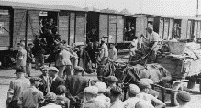  Prisoners were treated like cattle, herded onto crowded trains and locked inside for days as they travelled. Most had no light, food or drink, and only a bucket to use as a toilet. | What?  Prisoners had to stand with their hands above their heads to make space. | Key Fact:  Many of the very young, old and sick died because of the inhumane conditions.
 |  |  | Clothes | 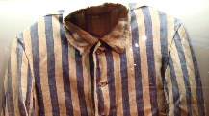 | After being separated from their families and registration, prisoners had their clothes stripped, their heads shaved, and were given a striped uniform and striped cap to wear. | What?  Prisoners were only allowed to change their clothes once every 6 weeks. | Key Fact:  Clothes were often stripped off dead prisoners and reused.
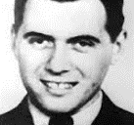  Dr Josef Mengele (1911-1979)  Dr Josef Mengele was an SS officer and physician in Auschwitz concentation camp. He performed many deadly human experiments on prisoners, gaining the nickname ‘The Angel of Death.’ He was also involved in the selection of prisoners for death, which others reported he ‘seemed to enjoy.’ At the end of the war, he escaped capture, dying a free man in Brazil years later. | 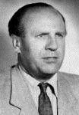  Oskar Schindler (1908-1974)  Oskar Schindler was an industrialist and member of the Nazi party, who is credited with saving 1,200 Jews during the Holocaust. He initially employed Jews in the interests of profit, but soon forged bonds with them, and showed initiative, courage, and dedication to save them. As time went on, he had to give Nazi officials increasing bribes to keep his workers safe. |  | Food | 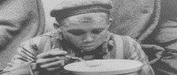 | Prisoners, received very little, if any, food. Watery soup was a staple lunch meal, with stale bread sometimes provided for dinner. | What?  The bread was supposed to last the prisoners for breakfast, too. | Key Fact:  Prisoners reported taking bread from those who had died in the night.
 |  |  | Work | 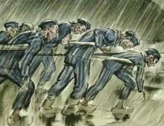 | Most prisoners worked outside doing heavy duty jobs such as factory or construction work. They often had to walk miles to work. Due to the insufficient food they were given, and widespread disease, many became too weak to work. They were then shot by SS soldiers. | What?  The prisoners provided free slave labour for many German companies. | Key Fact:  The life span of those working in the crematoriums was about 4 months.

1945 – The Nazis are defeated by the Allies to end WW2. The concentration camps are liberated.
1944 – Nazis take over Hungary and begin deporting 12,000 Jews a day.
1942 – Nazis discuss the ‘Final Solution’ of killing all European Jews.
1941 – Germany attacks the Soviet Union. Jews across Western Europe are forced into ghettos.
1939 – The Germans occupy Poland, and force Jews to leave their homes. WWII begins.
1940 – Jews put into concentration camps. Mass murder begins.
1935 – The Nuremburg laws took away the rights of Jews.
1933 – Adolf Hitler comes to power.
Holocaust Timeline

